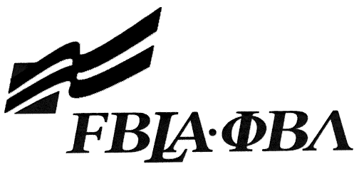 FBLA Statement of Assurance

Event Entry Form
This form must be completed and sent for the following events:
Check one: Computer Game & Simulation Programming Digital Design & Promotion
Desktop Application Programming E-business
Digital Video Production Web Site Design

Provide the URL for E-business and Web Site Design. These events will be judged online. Make sure the URL link is valid through the National Leadership Conference.

State: | VA |  | Check One: FBLA
School: |  | Burton Center for Arts and Technology
Web site URL Address: (where appropriate)
Member(s) Name: |  | Benjamin Culkin
Local Chapter Contact
Name:
Daytime/Cell Number:
Home E-mail:

I/We, the undersigned, attest that the design, creation, and implementation of the event are the original work of the above chapter member(s). I/we agree that this event may be linked, promoted, and used in any way by the national FBLA-PBL, Inc. for purposes of promoting the association. (Typed name is accepted for signature)
Name of Team Member  Benjamin Culkin |  | Adviser’s Name
Name of Team Member |  | Name of Team Member
Complete this Document Section for the Above Events (replaces Readme file):
Software Used: | Netbeans 7.0.1, JDK 6, OpenCSV library, & Matisse GUI Builder
Source of Information: | Sun JDK SE 6 Documentation
Copyright Notations | APACHE_20.txt
Instructions for Running Project: | Double-Click Start.bat
Template(s) Used (source) | Netbeans Source Templates

